Phase 6: Project Documentation

Project Title
AI Powered Malaria Detection Using Deep Learning

Team Members
Sanyog Jadhav
Sarthak Patil
Sarthak Kamtikar
Team Leader: Samruddhi Patil
GitHub Repository: https://github.com/Samruddhi1595/malaria_detection

System Overview
This project uses deep learning techniques to detect malaria parasites from microscopic blood smear images. A convolutional neural network analyzes the uploaded image and classifies it as parasitized or uninfected.

Technical Architecture
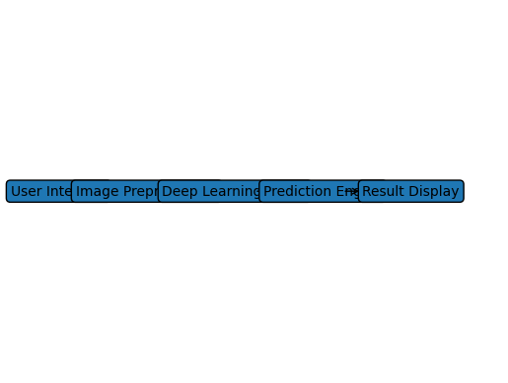

CNN Model Architecture
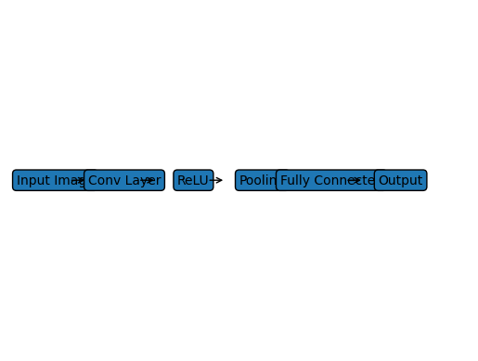

Technology Stack
Python
TensorFlow / Keras
OpenCV
NumPy
Deep Learning (CNN)

